**Setting up Application Environment**

**Docker CLI installation**

|  |  |
| --- | --- |
| Date | 4 November 2022 |
| Team ID | PNT2022TMID47261 |
| Project Name | Plasma Donor Application Using Cloud Computing |
| Maximum Marks |  |

Step 1: Download Docker from docker.dom and install it by running

the Docker Desktop Installer .exe file.

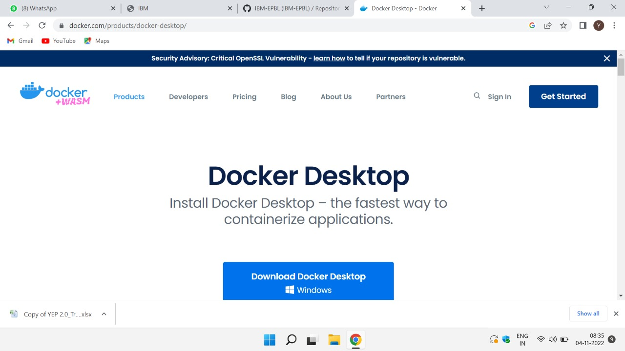

Step 2: Go to hub.docker.com register and create an account and

login with the same. 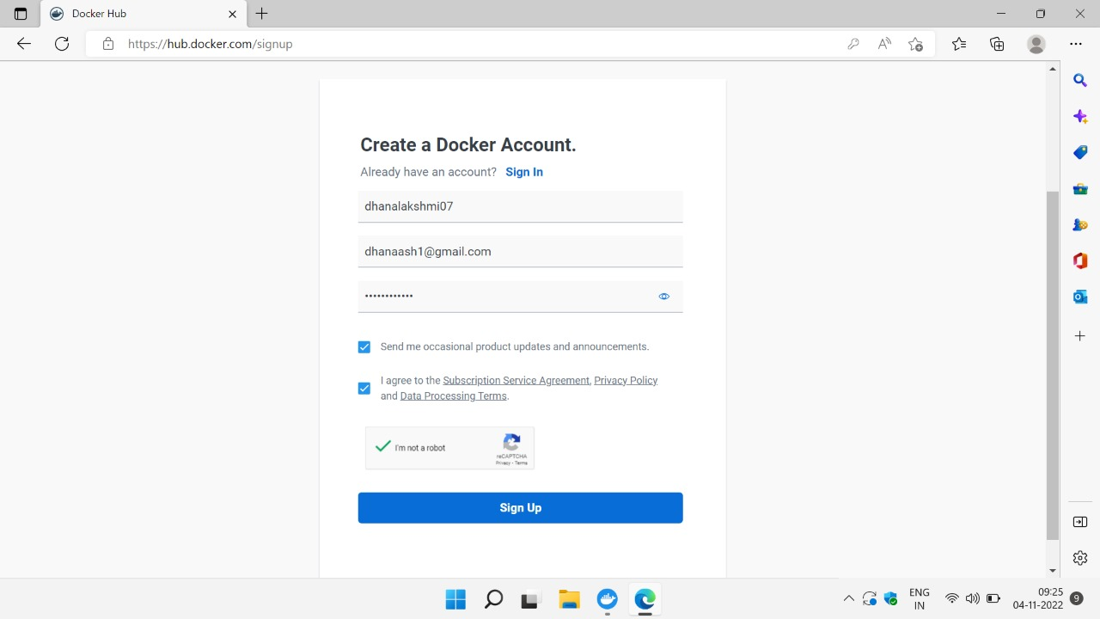

Step 3: Open Docker Desktop and start creating containers and

images.

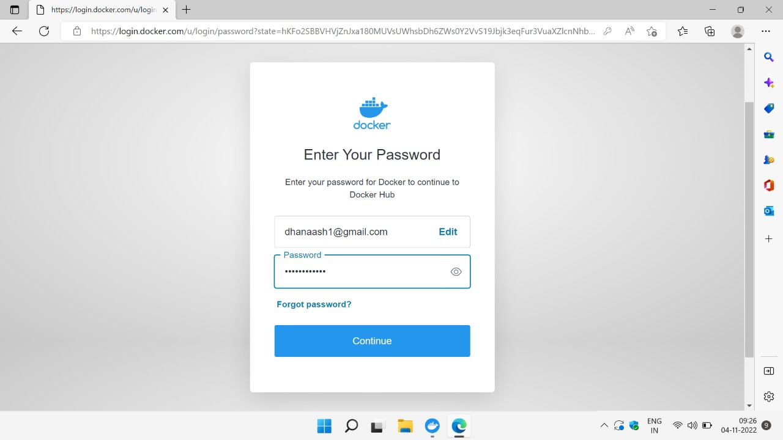

Step 4: Docker desktop is starting.

